Bachelor Thesis: Gamified Teleoperation Training in VR
- Simulate robotic arms in game environment using VR, and if possible integrate into reality using ROS/Serial. Requirements: UE/Unity, Robotic arms model, Inverse Kinematics, VR device (Meta Quest).
- Using camera to detect real objects in the robot’s workspace and spawn the objects in game environment. (real-virtual synchronization). Maybe using computer vision.
- The game serves as a training simulator, for example moving objects to a target area or stacking objects. Have scoring system like a normal game. Also to make people more familiar to do teleoperation with VR.
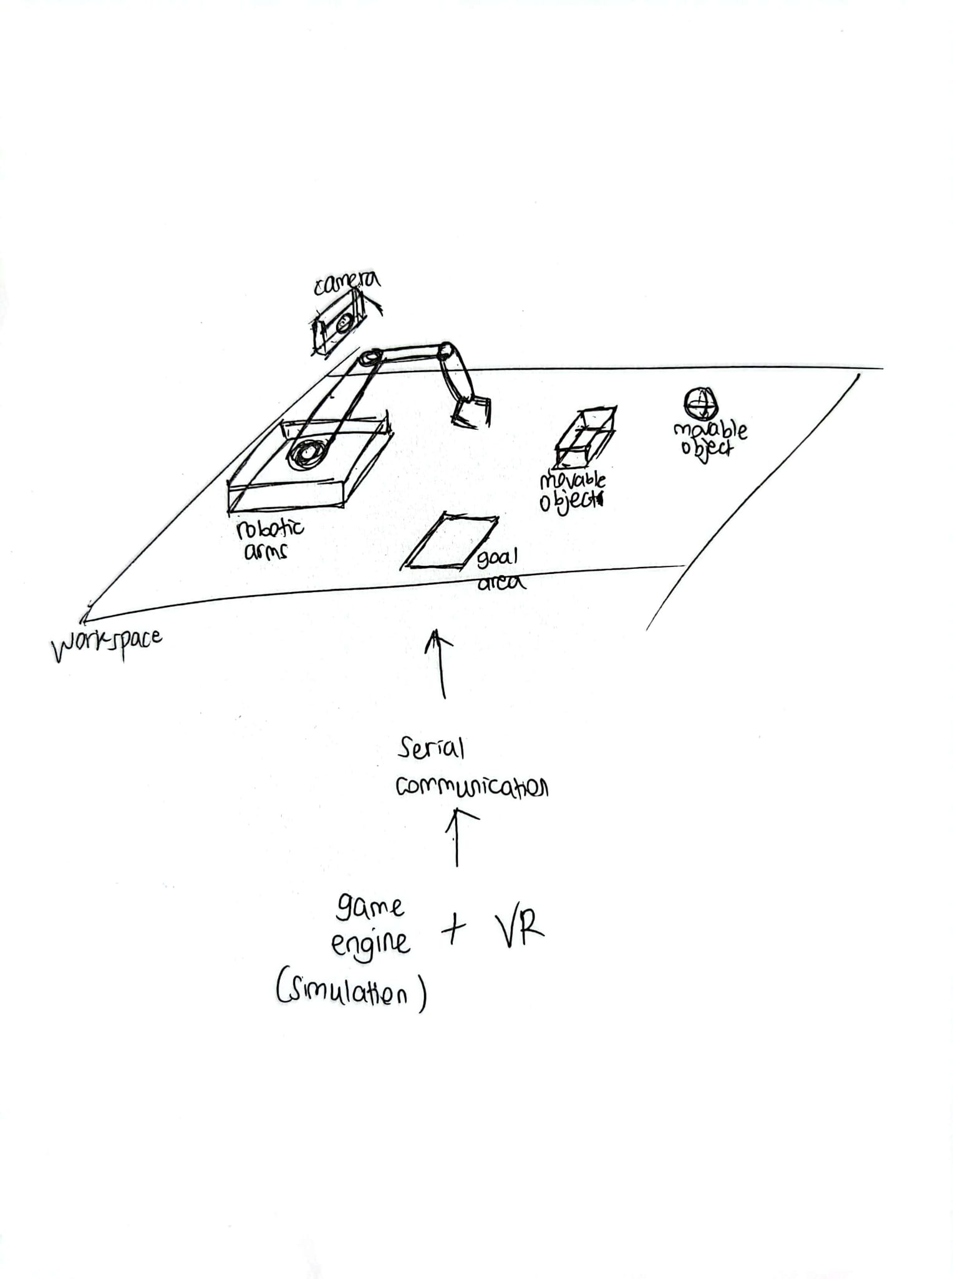

- This thesis presents the design and implementation of a modular VR robotic-arm visualization and simulation framework in Unity/Unreal Engine. The focus is on creating an extensible architecture that allows real-time, intuitive manipulation of robot kinematics in VR, intended as a foundation for future teleoperation, ROS integration, and mixed-reality robotic research.
- Using Right hand to control XZ-axis of the robot, and Left hand to control Y-axis, Pinch to grab things
- Robot joint angles displayed in VR
- Base for modular architecture for teleoperation in the future
- Adaptable for training, teleoperation, or simulation

